SCUBA-2 Block Specification
reply_queue

Created on: 7 October 2005
Last saved on: 07 October 2005
Table of Contents

1. Block Description 3
1.1 Block Hierarchy 3
1.2 Block Overview and Features 3
1.3 Detailed Description 3
2. Interface Description 4
2.1 Signals Description 4
2.2 Protocol / Interface Timing 4
3. Dataflow Description 5
4. State Machine Description 6
4.1 FSM 1 6
4.2 FSM 2 6
Files Associated with this Block 7

Block Description

Block Hierarchy

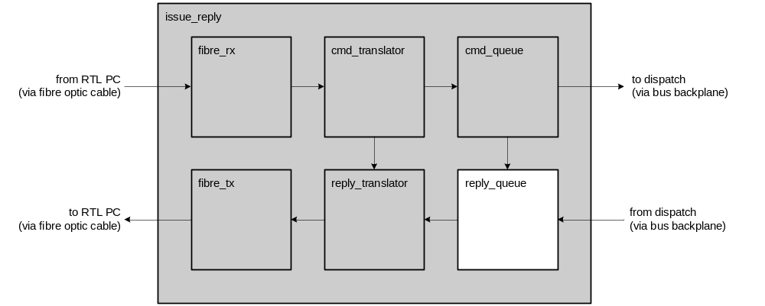

Block Overview and Features
In general, the reply_queue will monitor the uop_o and uop_rdy_o lines from the cmd_queue to learn what the next micro-op response should be. When the cmd_queue asserts uop_rdy_o, the reply_queue assumes that the uop_o bus has valid data on it, and actively waits for responses to return from the various cards that were addressed by the micro-op over the lvds_rx lines. As responses arrive, the reply_queue assembles them into a single data packet in reply to the micro-op that generated the responses. When the data packet is complete and ready to be transmitted to the reply_translator, the reply_queue asserts uop_ack to notify the cmd_queue to retire the current micro-op and move on to the next one.

Detailed Description
There are 3 possible error conditions that the reply_queue needs to handle:
- A reply that it receives has already timed out. This indicates that a reply took longer than expected to execute, and that its proper execution in the system is suspect. This does not indicate that the command was issued late, because only commands that have NOT expired are issued by the cmd_queue. Thus, if a reply is assembled by the reply_queue, and it asserts the uop_ack signal to the cmd_queue while the reply has already expired, then the reply_queue will set a flag to the reply_translator that the response is in error. However, the cmd_queue will proceed as usual, and need not know that the reply failed, because there is not enough bandwidth in the system to re-issue a command if it has already expired. It will be left up to the Realtime Linux PCs to determine what to do with the error response that the reply_translator then sends it (through fibre_tx).
- A reply has an incorrect checksum. This indicates that there was a transmission error over the bus backplane from the dispatch block to the reply_queue block. This does not indicate that the error occurred on the length of backplane from the cmd_queue block to the dispatch block, because the dispatch block drops bad packets, and re-synchronizes on the next packet.
If a packet is received by the reply_queue and has an incorrect checksum, the reply_queue will discard the entire reply that the packet contributes to. Because the packet is untrustworthy, the reply_queue cannot use any information from it to generate an error response. Instead, it will use the micro-op data asserted by the cmd_queue on its uop_o bus to generate a valid error response to the reply_translator.
- If the bus backplane receivers/transmitters drop a packet at any point in the system, the reply_queue will not receive a response that it’s looking for based on what the cmd_queue shows on its uop_o bus. In this case, if a reply arrives from a card that the reply_queue is expecting another reply from (this is the only condition that guarantees that data packets were dropped, and that the reply_queue can legally generate a response without being confused by a valid response later), the reply_queue will use the micro-op data asserted by the cmd_queue on its uop_o bus to generate a valid error response to the reply_translator and retain the data packet that it has assembled and compare it to the next micro-op that the cmd_queue asserts on the uop_o bus. The only way that this can work properly is if replies retire in order of dispatch – otherwise the cmd_queue has no way of determining what command was dropped.

Interface Description

Signals Description
 | Description | Direction
Global Signals
(Other signals 1)
(Other signals 2)

Protocol / Interface Timing
[insert timing diagrams here]

Dataflow Description

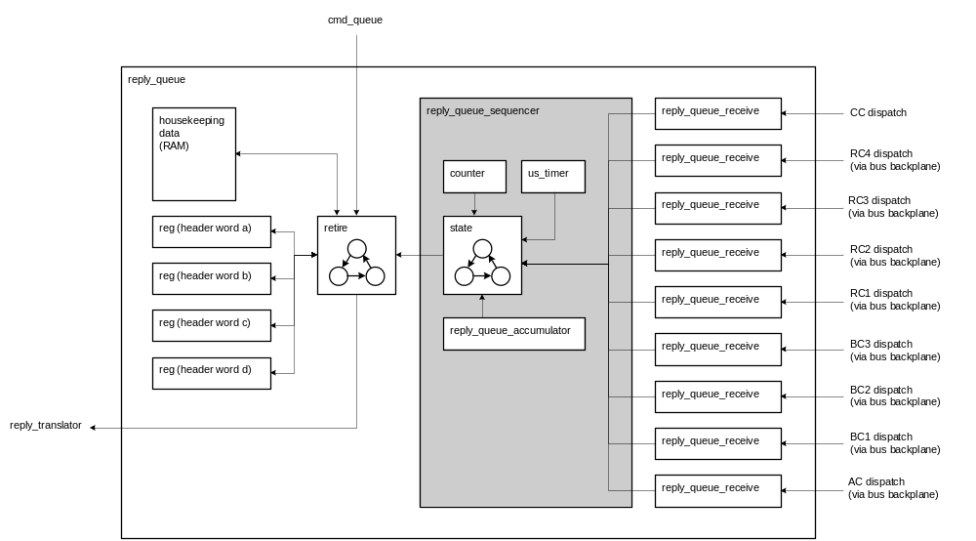

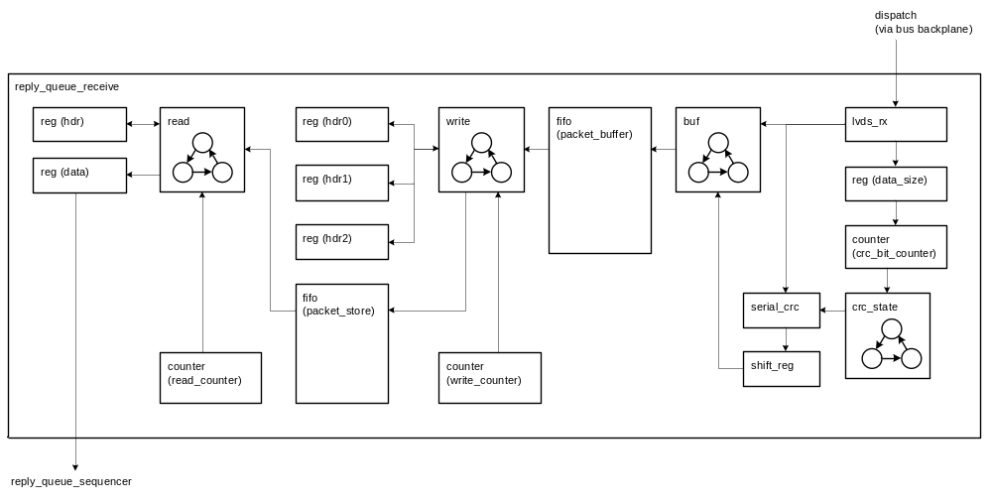

State Machine Description

FSM 1
[insert ASM chart here]

FSM 2
[insert ASM chart here]

Files Associated with this Block

File | Description
[list all files that belong to this module] | [and enter a short description beside each]

